Cryptography Experiment Report
Date: January 23, 2026
Analyst: Nishanth.C
Tools Used: OpenSSL, Linux Terminal
Objective: To demonstrate the practical application of encryption, hashing, and digital signatures.
This report documents the successful implementation of cryptographic primitives. We tested Symmetric Encryption for data confidentiality, Asymmetric Encryption for secure key exchange, and Hashing for data integrity. All operations were performed using the standard OpenSSL library.

- Technical Findings
  - Symmetric Encryption ( AES – 256-CBC)
    - Observation: The encryption process was fast and required a shared password.
    - Result: The file secret.txt was converted into unreadable ciphertext. Without the correct password, the content was inaccessible.
    - Use Case: Best suited for encrypting large amounts of data due to its speed.
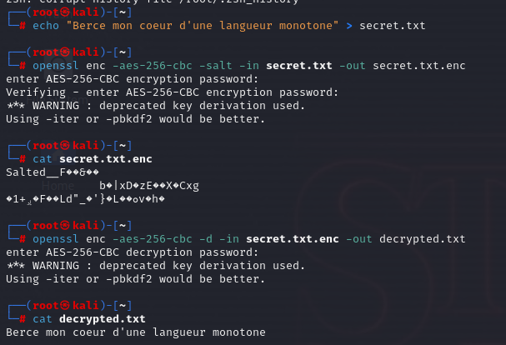
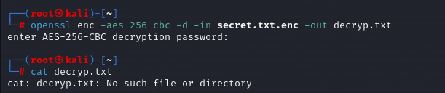

  - Asymmetric Encryption ( RSA-2048)
    - Observation: This required generating a key pair.
    - Result: Data encrypted with the Public key could only be decrypted by the Private Key. This demonstrated how two parties can communicate securely without ever meeting to swap passwords.
    - Use Case: Best suited for key exchange or digital signatures.
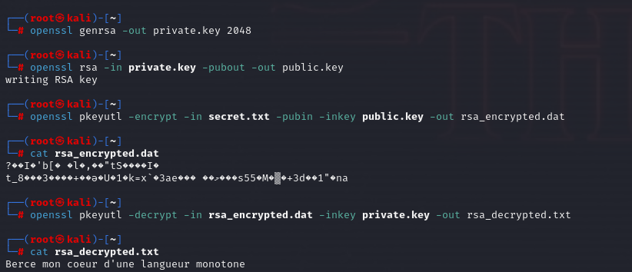
  - Hashing ( SHA-256 )
    - Original Hash: e49c733f999c
    - Modified Hash: dbecd6ccb6e7
    - Conclusion: Even a minor change to the file content resulted in a completely different hash value. This confirms hashing is an effective method for “File Integrity Monitoring.”
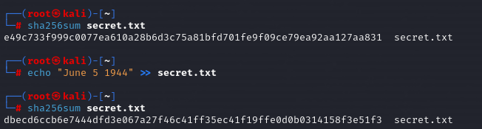

- Real-World Application Analysis
- HTTPS: Uses a hybrid approach. It uses Asymmetric Encryption to securely exchange a temporary key and then switches to Symmetric Encryption to transfer the actual webpage data because AES is faster.
- Digital Signatures: Used in software updates to ensure the update comes from the actual vendor and hasn’t been tampered with by a hacker.

- Conclusion
Cryptography is the backbone of modern security.
- Confidentiality is achieved via Encryption.
- Integrity is achieved via Hashing.
- Authentication is achieved via Digital Signatures.

